**OLABISI ONABANJO UNIVERSITY**

College of Engineering & Environmental Studies

Faculty of Engineering

Ibogun Campus.

**MECHANICAL ENGINEERING DEPARTMENT**

**MECHANICAL ENGINEERING PROGRAMME**





**FLUID MECHANICS**

**LABORATORY MANUAL**

**300 LEVEL**

**NAMES…………………………………………………………………………………………**

**MATRIC. NO. :…………………………… LEVEL: ………………………………………**

**DEPT.: ……………………………………...GROUP NO:...…………………………………**

**COURSE:……………………………………. CODE: …..…………………………………..**

**DATE:………………… SESSION: ……………………SIGNATURE…………………….**

**FLUID MECHANICS LABORATORY (300 LEVEL)**

**EXPERIMENT**

**TITLE: FLOW THROUGH AN ORIFICE**

**Introduction**

The discharge of a fluid when passes through a constriction, such as sharp-edged hole or over a weir, is considerably less than the amount calculated on the assumption that the energy is conserved and that the flow through the constriction is uniform and parallel. The reduction in flow is normally due to the contraction of the stream, which takes place through the restriction and continues for some distance down-stream of it, rather than to a considerable energy loss. The objectives of the experiments are to:

(i) determine the coefficient of velocity Cu, the coefficient of contraction Cc and coefficient of discharge Cd at single constant value of head Ho.

(ii) determine these coefficients through the experiment done at various values of head Ho.



**Figure 1.1: Flow through an orifice equipment**

**THEORY**

The essential feature of flow through the orifice is showing in figure below. The tank is assumed to be sufficiently large for the velocity of flow in it to be negligibly small, except at a point close to the orifice. In the vicinity of the orifice, the fluid accelerates towards the centre of the hole, so that as the jet emerges it suffers a reduction of area due to the curvature of the streamlines as typified by the streamline MN indicated. The reduction of the area due to this local curvature may be taken to be complete at about half the orifice diameter downstream of the plane of the orifice, the reduced section is usually referred to as the vena contracta.



**Figure 1.2: Diagrammatic Sketch of Flow through an Orifice.**

The pressure everywhere on the surface of the jet is atmospheric, but within the jet the pressure does not fall to atmospheric until the acceleration is complete i.e. until the vena contracta is reached. Consider now the total head of the water at point M and N of a typical streamline, form Bernoulli equation M being in the surface and N being in the plane of the vena contracta. From Bernoulli’s equation, the total head at M is

U2m + Pm + Zm

2g w

and at N is U2n + Pn + Zn

2g w

The energy conserved with no loss of total head

U2m + Pm  + Zm = U2n  + Pn + Zn …… (1)

2g w 2g w

*Pn = PN, Un  = 0, Zm – Zn = Ho and Zm - Zn = U0 …… (2)*

From equ (1) & (2) the ideal velocity at N is given by U2m  = Ho

This result applies to all points in the plane of the vena contracta, so changing the notation form UN as the ideal velocity in the plane of the vena contracta, which would occur if there was no energy loss.

∴ U2o = Ho ……… (3)

2g



Because of the energy loss, the actual velocity U in the plane of the vena contracta will be less than Uc and may be calculated from the pitot-tube reading by the equation.

U2c = Hc ………. (4)

2g

⇒ 

It is clear that (H0 - Hc) represents the energy loss. The ratios of actual velocity Uc and the ideal velocity Uo is often referred to as the coefficient of velocity Cu of the orifice.

From equation (3) & (4), we have

Cu  = Uc = Hc = Hc1/2

Uo Ho ….. (5)

Similarly, the coefficient of contraction Cc is defined as the ratio of X-section area of the Vena Contracta ac to the X - section area of the orifice ao

i.e. Cc = ac/ao ..…..(6)

The coefficient of discharge Cd is defined as the ratio of the actual discharge to that which would take place if the jet discharged at the ideal velocity without reduction of area.

The actual discharge Qc is given by s

Qc  = Ucac ..………. (7)

If the jet discharged at the ideal velocity Uo over the orifice area ao the discharge Qo would be

Qo = Uo ao = ao (2g H0)1/2 ...………. (8)

From the definition of the coefficient of discharge.

Cd  = Qc = Ucac

Qo Uoao

In terms of experimental quantities measured, coefficient of discharge is given by:-

Cd = Q

(2gH0)1/2 a0

From equ. 5 & 6, Cd = CuCc



Coefficient of velocity,





Coefficient of discharge, 

***Procedure***

Set the equipment on a bench and levelled so that the base of the tank is horizontal. The flexible supply pipe from the bench control valve is connected to the inlet pipe of the apparatus, which is positioned to discharge directly back of the weigh tank and the overflow of the apparatus is directed onto the bench top. To obtain the steadiest readings, the vertical position of the inlet pipe should be adjusted to be just submerged. The diameter of the sharp edge orifice is noted.

**EXPERIMENT 1**

**Title:** Flow through the orifice.

**Objectives**: to determine the coefficient of velocity Cu, the coefficient of contraction Cc and coefficient of discharge Cd at single constant value of head Ho.

**Procedure**: Same as above on the flow through the orifice experiment.

In the first part of the experiment, water is admitted to the tank to allow it to fill the height of the overflow pipe and the inflow to regulate so that a small steady discharge is obtained from the overflow. This ensures that the level in the tank remains constant while measurements are made.

To measure Cd, the discharge is obtained by collection of a specified quantity: 5, 10, 15, 20, 25, 30 litres of water from the orifice in the weighing tank, and recording the time taken. This can be repeated 3 or 4 times and the results can be computed. The value of constant head Ho on the orifice should be recorded.

To measure Cu, the pitot-tube is inserted into the emerging jet close to the underside of the tank, and the value of pitot head Hc and head Ho on the orifice are noted.

To measure Cc it is necessary to find the diameter of the jet at the vena contracta. This is done by using the sharp-edged blade attached to the head of the pitot-tube, the plane of the blade being normal to the direction of transverse of the tube. The blade is brought to each edge of the jet in turn just below the tank, and the positions of the tube as read on the lead screw and graduated nut read in each case. The difference of the readings represents the diameter of the jet. The result should be presented as follows:

**Results and calculations**

The result is presented as follows:

Diameter of orifice, do = ….. (mm)

Cross-sectional area of orifice, ao = ….. (m2)

Head on orifice, Ho = ….. (mm)

Average time required to collect known volume (say 10litres) of water, t = .. (s)

Discharge Q = volume/t= 10 = ……. (m3/s)

103  x t

Pitot-tube readings, Ho = ….. (mm)

Diameter of jet at contracta, dc  = ….. (mm)

Area of jet at contracta, ao = ….. (m2)



Coefficient of contraction, Cc =

Coefficient of discharge, Cd = Q

ao (2gHo)1/2 =

Coefficient of velocity, Cu =

**Exercises:**

1. Measure the orifice diameter, do
2. Calculate the area of orifice, ao
3. Determine the orifice head Ho
4. Determine the average time used to collect 10liters of water
5. Determine the pitot tube reading, Hc
6. Measure the Jet diameter at contracta, dc
7. Calculate the area of the jet at contracta, ac
8. Calculate the coefficient of contraction, Cc
9. Calculate the coefficient of discharge, Cd
10. Calculate the coefficient of Velocity, Cu

***PRACTICAL REPORT***

***EXPERIMENT 1***

***Title:………………………………………………………………………………………………***

***Aims/Objectives:***

***……………………………………………………………………………………………………..***

***……………………………………………………………………………………………………..***

***Equipment/Apparatus/Materials:***

***………………………………………………………………………………………………………***

***Theory:***

***………………………………………………………………………………………………………***

***………………………………………………………………………………………………………***

***………………………………………………………………………………………………………***

***………………………………………………………………………………………………………***

***………………………………………………………………………………………………………***

***………………………………………………………………………………………………………***

***Diagram(s):***

Diameter of orifice, do = ....................................................................................….......................................

Cross-sectional area of orifice, ao = .............................................................................................................

Head on orifice, Ho = …........................................................................................ ........................

Average time required to collect known volume (say 10litres) of water, t(s) ................................................................................................................................................................................................................................................................................................................................................

Discharge Q = volume/t = 10 = …….............................................................................. (m3/s)

103 * t

Pitot-tube readings, Ho = .......................................................................….. (mm)

Diameter of jet at contracta, dc = ....................................................................…......(mm)

Area of jet at contracta, ao = ........................................................................….. (m2)

Coefficient of contraction, Cc = ..............................................................................................................................................................................................................................................................................................................................................

Coefficient of discharge, Cd  =

........................................................................................................................................................................................................................................................................................................................................................................................................................................................................................................................

Coefficient of velocity Cu = .........................................................................................................................................................................................................................................................................................................................

**EXPERIMENT 2:**

**Title:** The correlation between the orifice head and discharge.

**Objective**: To establish the relationship between discharge and head on the orifice.

**Theory**: It is a follow up to the experiment on flow through the orifice.

**Procedure**: It is a follow up to the experiment on flow through the orifice.

In the second part of the experiment the inflow to the tank is reduced to lower the level in the tank in stages, the discharge from the orifice being measured at each stage. Care should be taken to allow the level to settle to a steady value after the inflow to the tank has been changed and it is advisable to read this level several times while the discharge is being collected and to record the mean values over the time interval. About eight difference flow rates should be sufficient to establish the relationship between discharge and head on the orifice. The experiment could be performed for the following head, Ho on the orifice: 200, 220. 250, 280, 300, 320, 350 and 380mm.

The results should be tabulated as shown below:

Table 2.1: Table of results

|  |  |  |  |  |  |  |
| --- | --- | --- | --- | --- | --- | --- |
| Qty (Lts) | Ho(mm) | t1(sec) | t2 (sec) | t average (sec) | H1/2o(m1/2) | 103 x Q(m3/s) |
|  |  |  |  |  |  |  |

***Exercises:***

From the data gotten in the second part of the experiment

1. Plot a graph of Q vs Ho1/2

2. Calculate the slope of the above graph and hence or otherwise, calculate the value of Cd.

3. Compute the Cd obtained above with Cd calculated from the data obtained in the first part of the experiment.

4. What suggestions have you for improving the apparatus?

5. If, when you plot the graph of H01/2 against Q you obtain a line which does not appear to pass through the origin, what possible reasons are there for this? How will the value of Cd obtained from the graph be affected?

6. It is assumed that the tank is sufficiently large for the velocity of flow towards the orifice to be neglected. Is this justified? If the plan area of the tank is 4.12 x 10-2m2, what is the velocity of approach when the discharge is 1.97 x 10-4m3/s, and what velocity head does this correspond to?

7. Supposing that it is not possible to measure the diameter of the jet at the vena contracta, but that the diameter is measured some distance below it, would the results be affected? If so, estimate the change in diameter of the jet at the vena contracta and at a plane lying 25mm below it.

***PRACTICAL REPORT***

***EXPERIMENT 2***

***Title:………………………………………………………………………………………………***

***Aims/Objectives:***

***……………………………………………………………………………………………………..***

***……………………………………………………………………………………………………..***

***Equipment/Apparatus/Materials:***

***………………………………………………………………………………………………………………………………………………………………………………………………………………***

***Theory:***

***………………………………………………………………………………………………………***

***………………………………………………………………………………………………………***

***………………………………………………………………………………………………………***

***………………………………………………………………………………………………………***

***………………………………………………………………………………………………………***

***………………………………………………………………………………………………………***

***………………………………………………………………………………………………………***

***………………………………………………………………………………………………………***

***………………………………………………………………………………………………………***

***………………………………………………………………………………………………………***

***Diagram(s):***

***Results:*** The results should be tabulated as shown below:

Table 2.1: Table of results

|  |  |  |  |  |  |  |
| --- | --- | --- | --- | --- | --- | --- |
| Qty (Lts) | Ho(mm) | t1(sec) | t2 (sec) | t average (sec) | H1/2o(m1/2) | 103 x Q(m3/s) |
|  |  |  |  |  |  |  |
|  |  |  |  |  |  |  |
|  |  |  |  |  |  |  |
|  |  |  |  |  |  |  |
|  |  |  |  |  |  |  |
|  |  |  |  |  |  |  |

Notes:

............................................................................................................................................................................................................................................................................................................................................ ……………………………………………………………………………………………………………………………………………………………………………………………………………………………………………………………………………………………………………………………………………………………………………………………………………………………………………………….................................................

............................................................................................................................................................................................................................................................................................................................................ ……………………………………………………………………………………………………………………………………………………………………………………………………………………………………………………………………………………………………………………………………………………………………………………………………………………………………………………….............................................................................................................................................................................................................................................................................................................................................................................................………………………………………………………………………………………………………………………………………………………………………………………………………………………………………………………………………………………………………………………………………………………………………………………………………………………………………………………..............................................................................................................................................................................................................................................................................................................................................................................................……………………………………………………………………………………………………………………………………………………………………………………………………………………………………………………………………………………………………………………………………………………………………………………………………………………………………………………….............................................................................................................................................................................................................................................................................................................................................................................................……………………………………………………………………………………………………………………………………………………………………………………………………………………………………………………………………………………………………………………………………………………………………………………………………………………………………………………….............................................................................................................................................................................................................................................................................................................................................................................................………………………………………………………………………………………………………………………………………………………………………………………………………………………………………………………………………………………………………………………………………………………………………………………………………………………………………………………..................................................

***(a) Graph***

***Title:***

***Scale:***

***Graph***

***Title:***

***Scale:***

Notes:

.........................................................………………………………………………………………………………………………………………………………………………………………………………………………………………………………………………………………………………………………………………………………………………………………………………………………………………………………………………………………………………………………………………………………………..............................................................................................………………………………………………………………………………………………………………………………………………………………………………………………………………………………………………………………………………………………………………………………………………………………………………………………………………………………………………………………………………………………………………………………………………………………………………………………………………………………………………………………………………………………………………………………………………………………………………………………………………………………………………………………………………………………………………………………………………………………………………………………………………………………………………………………………………………………………………………………………………………………………………………………………………………………………………………………………………………………………………………………………………………………………………………………………………………………………………………………………………………………………………………………………………………………………………………………………………………………………………………………………………………………………………………………

.........................................................………………………………………………………………………………………………………………………………………………………………………………………………………………………………………………………………………………………………………………………………………………………………………………………………………………………………………………………………………………………………………………………………………..............................................................................................………………………………………………………………………………………………………………………………………………………………………………………………………………………………………………………………………………………………………………………………………………………………………………………………………………………………………………………………………………………………………………………………………………………………………………………………………………………………………………………………………………………………………………………………………………………………………………………………………………………………………………………………………………………………………………………………………………………………………………………………………………………………………………………………………………………………………………………………………………………………………………………………………………………………………………………………………………………………………………………………………………………………………………………………………………………………………………………………………………………………………………………………………………………………………………………………………………………………………………………………………………………………………………………………

.........................................................………………………………………………………………

**EXPERIMENT 3:**

**Title: Coefficient of a pitot tube**

**Objective:** To find the value of velocity head and to find the coefficient of a pitot tube.

**Apparatus:** A pitot tube, A small rectangular channel (or a pipe) with water flowing through it.

**Theory:**

A pitot tube is a small open tube bent at right angle and is placed in flow such that one leg is vertical and the other leg is horizontal (Fig. 6). It is used to measure the velocity of flow at any point in a pipe or channel. *It works on the principle that if the velocity of flow at any point becomes zero, the pressure there is increased due to conversion of the kinetic energy into pressure energy.* The velocity of flow (*V*) is determined by measuring the rise of liquid (*h*) in the tube from the equation:

***Figure 3.1: Pitot tube***

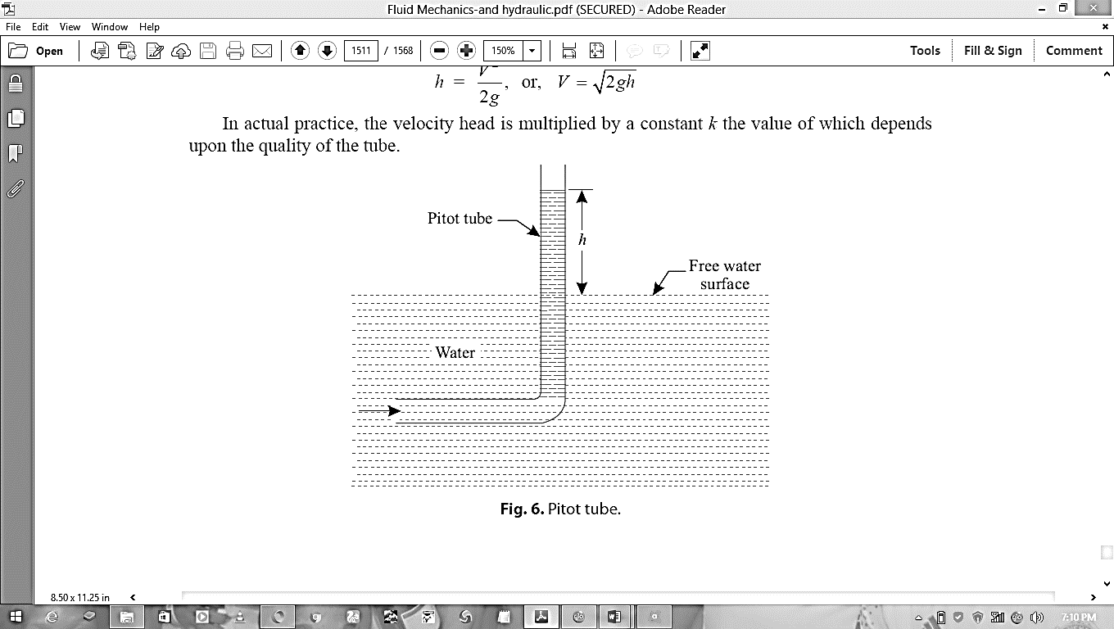

*2gh*

*h = V 2*  or *V =*

*2g*

In actual practice, the velocity head is multiplied by a constant *K,* the value of which depends upon the quality of the tube.

*... Kh = V 2*

*2g*

The value of *K* is determined by actually measuring the velocity and the velocity head ‘*h*’.

**Procedure:**

1. Place the pitot tank in the moving water properly.

2. Note down the reading of ‘*h*’.

3. Repeat the experiment by placing the pitot at different depths, find the mean value of ‘*h*’ and hence determine the velocity.

4. To find the value of ‘*K*’, measure the actual velocity of flow (*V*) with the help of a “current meter” and use the following relation:

*V 2* = *V 2*

*K mean*

*2g 2g* The value of ‘*K*’ varies from 0.9 to 0.99

**Precautions:**

1. Note down the readings accurately.

2. A pitot tube should be used preferably in pipes or channels with *shallow water* moving at *high velocity* (as good results are obtained under these conditions).

**Table 3.1: Pitot tube/Current meter – Observations**

|  |  |  |
| --- | --- | --- |
| *S/N* | *Velocity head reading ‘h’* | *Current meter reading* |
| 1.  2.  3.  4. |  |  |

Mean value, ‘*h*’ = ……………. Mean value, current meter = …………………

Now, mean velocity head, *h = V 2*

*mean*

*2g*

*Vmean =* …………….

Again, mean velocity as obtained from current meter reading

*V =* ……………….

... Coefficient of the meter,

Determine the value of K= $K = V^2mean/V^2$

**Conclusions:**

***PRACTICAL REPORT***

EXPERIMENT 3

Title:………………………………………………………………………………………………

Aims/Objectives:

……………………………………………………………………………………………………..

……………………………………………………………………………………………………..

Equipment/Apparatus/Materials:

………………………………………………………………………………………………………………………………………………………………………………………………………………

Theory:

………………………………………………………………………………………………………

………………………………………………………………………………………………………

………………………………………………………………………………………………………

………………………………………………………………………………………………………

………………………………………………………………………………………………………

………………………………………………………………………………………………………

………………………………………………………………………………………………………

………………………………………………………………………………………………………

………………………………………………………………………………………………………

………………………………………………………………………………………………………

Diagram(s):

Notes:

………………………………………………………………………………………………………………………………………………………………………………………………………………………………………………………………………………………………………………………………………………………………………………………………………………………………

………………………………………………………………………………………………………………………………………………………………………………………………………………

………………………………………………………………………………………………………

............................................................................................................................................................................................................................................................................................................................................................................................................................................................................................................................................................................................................................................................................................................................................................................................................

………………………………………………………………………………………………………………………………………………………………………………………………………………………………………………………………………………………………………………………………………………………………………………………………………………………………

………………………………………………………………………………………………………………………………………………………………………………………………………………

………………………………………………………………………………………………………

............................................................................................................................................................................................................................................................................................................................................................................................................................................................................................................................................................................................................................................................................................................................................................................................................

………………………………………………………………………………………………………………………………………………………………………………………………………………………………………………………………………………………………………………………………………………………………………………………………………………………………

………………………………………………………………………………………………………………………………………………………………………………………………………………

………………………………………………………………………………………………………

............................................................................................................................................................................................................................................................................................................................................................................................................................................................................................................................................................................................................................................................................................................................................................................................................

………………………………………………………………………………………………………………………………………………………………………………………………………………………………………………………………………………………………………………………………………………………………………………………………………………………………

………………………………………………………………………………………………………………………………………………………………………………………………………………

………………………………………………………………………………………………………

........................................................................................................................................................................................................................................................................................................................

**Topic: Energy loss in pipes**

**Experiment**

**4 Energy losses in pipes for a turbulent flow**

**5 Determination of the energy loss in a turbulent flow**

**6 Determination of the number of Reynolds for a turbulent flow**

**7 Energy loss in pipes for a laminar flow**

**8 Determination of the energy loss factor *f* for a pipe with laminar flow**

**9 Determination of the number of Reynolds for the laminar flow**

**10 Determination of the kinematic viscosity of water**

**Introduction**

The unit consists of different elements that are used in conjunction with the Hydraulic Bench:

* A water hose with quick connector to be plugged to water outlet of the Hydraulic Bench.
* Metallic test pipe of 6mm of external diameter and 4mm of interior diameter.
* Water column manometer and bourdon manometers.
* Constant height tank

The equipment and materials required are Hydraulic bench, energy losses in pipes, graduated test tube, chronometer/stop watch, thermometer and water.

**Diagram**

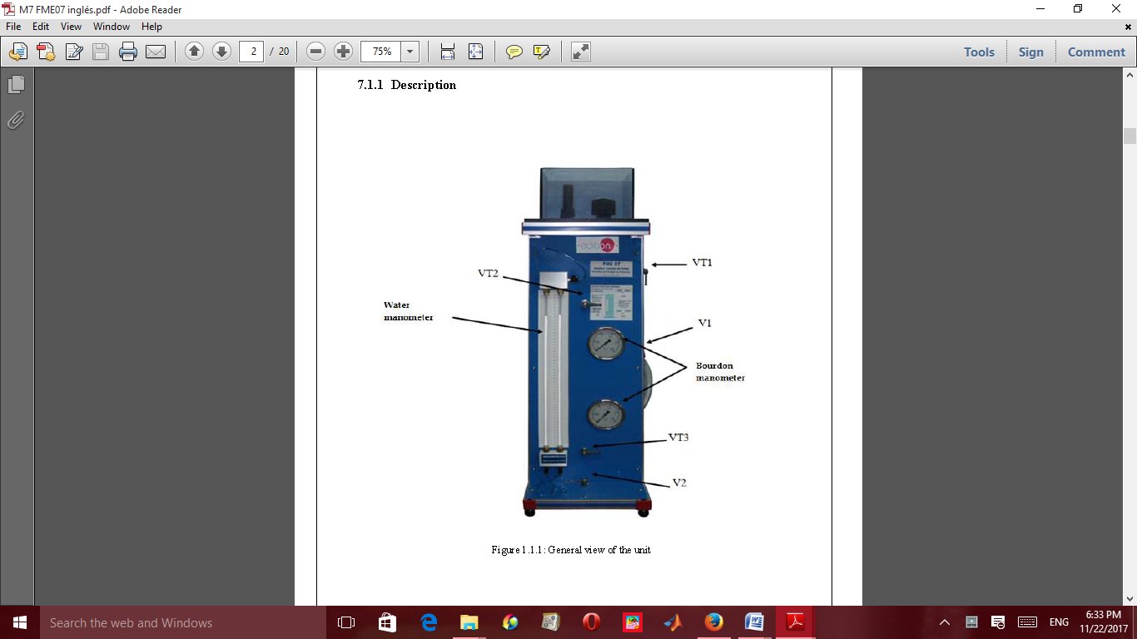

**Figure 4: Energy loss in pipe equipment**

**THEORY**

The energy losses in pipes are measured in meters of column of fluid circulating in the pipe, and they are related with the velocity.

These energy losses approach is expressed by the Darcy formula:

Where: *V =* fluid velocity

*D =* pipe diameter

*L =* pipe Length

*g =* gravitational acceleration

For a straight flat pipe, we have that: and

Where 𝜐 is the kinematic viscosity, 𝜐 = m2/s and *Re* is the number of Reynolds.

For a laminar regimen we have that: $f=16/Re$

Yielding

$$hf =32*υ*L*(V/g*ρ*D^2)$$

Note: Test pipe diameter is 4 mm and 500 mm long.

Manometer scale: 0 to 500 mm.

The volume of liquids is usually measured in **litres** or **millilitres.**

1 litre = 1000 ml and 1 ml = 1 cm3

1 litre = 1000 cm3 and 1 m3 = 1000 litres

**Experiment 4**

**Title: Energy losses in pipes for a turbulent flow**

**Objective:** The objective is to investigate how the load loss by friction varies with high velocities along a cylindrical test pipe.

**Equipment/Apparatus/Materials:** Hydraulic bench, Energy losses in pipes, Chronometer/stop watch, Thermometer, Test tube.

Diagram

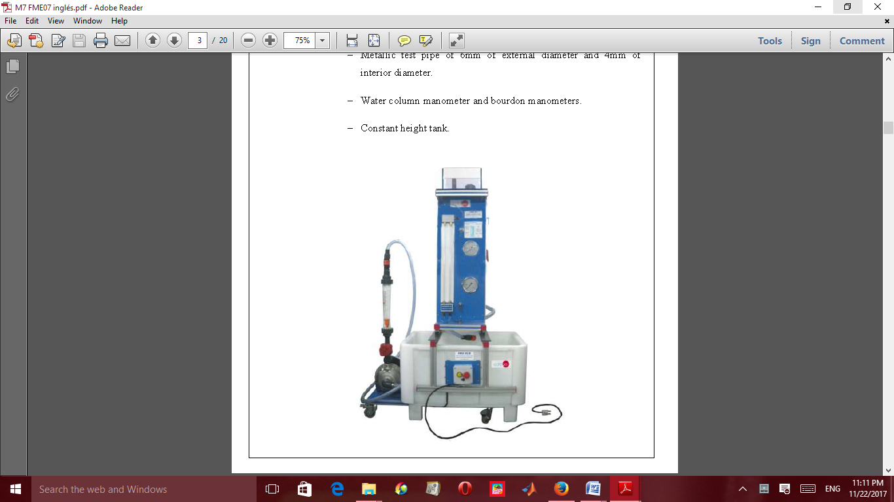

**Figure4.1: Volumetric bench assembly with energy loss in pipe equipment**

**Procedure**

1. Place the energy loss in pipe unit on the channel guides of the hydraulic bench.
2. Connect the flexible hose input duct of the device directly to the driving mouth of the bench.
3. Close V1 and set VT1 in turbulent flow position.

iv.      Close the flow control valve of the hydraulic bench

1. Start the pump and open the control valve of the supply.
2. Open the control valve completely V2, then prepare the test pipe and the rest of the conducts.
3. Use the three-ways valves VT3 of the water manometer, to allow water

     circulate through all the ducts until all the air has been expelled.

1. Select the bourdon manometers with VT2 and VT3, when high

pressures are obtained.

ix. Once the unit is ready, you can proceed to take data.

x. To get the maximum flow, open valve V2 of the unit completely.

xi. Take the readings in the manometers.

xii. Using the bourdon manometers, measure the flow in function of the

opening of valve V2.

xiii. Determine the average velocity of the current.

xiv. Measure the water temperature.

**Results**

Test pipe length (L) = 500 mm.

Test pipe internal diameter (Di) = 4 mm.

**Table**

|  |  |  |  |  |  |
| --- | --- | --- | --- | --- | --- |
| **Water kinematic viscosity** 𝜐 **(mm2/s)** | 1.163 | 1.106 | 1.053 | 1.0038 | 0.914 |
| **Temperature (ºC)** | 14 | 16 | 18 | 20 | 24 |

Record the values of parameters measured from the experiments for the different flows of volume taken and their individual scale readings in the manometers, with the intention of finding, the energy loss for friction of the water through the test pipe (that may be due to the difference of heights in manometers in each case).

**Table 4.1: Table of values**

|  |  |  |  |  |  |  |  |
| --- | --- | --- | --- | --- | --- | --- | --- |
| S/N | Volume (l) | Time (s) | Flow (m3/s) | Readings of the water  manometer h1 h2  (w.c.mm.) (w.c.mm.) | Readings of the bourdon manometers (bar) | Temp(0C) | Energy  Loss  (w.c.m.) |
|  |  |  |  |  |  |  |  |
|  |  |  |  |  |  |  |  |
|  |  |  |  |  |  |  |  |
|  |  |  |  |  |  |  |  |
|  |  |  |  |  |  |  |  |

Exercises

1. Calculate the area (A) of the test pipe.
2. Calculate and write down the values of the average velocity of the current, *V*.
3. Calculate the Velocity of fluid for each flow and the average Velocity.
4. Determine the Reynolds Number (Re) for each flow.
5. Calculate the frictional factor (f) for each flow.
6. Determine the energy loss in the pipe (hf).

Show your calculations and tabulate your results on the table.

**Experiment 5**

**Title:** Determination of the energy loss in a turbulent flow

**Equipment/apparatus/Materials:** Hydraulic Bench, Energy losses in pipes, Graduated test tube, Chronometer/stop watch, Thermometer

**Diagram**



**Figure 5.1: Energy loss in pipe equipment**

**THEORY**

The energy losses in pipes are measured in meters of column of fluid circulating in the pipe, and they are related with the velocity.

These energy losses approach is expressed by the Darcy formula:

Where: *V =* fluid velocity

*D =* pipe diameter

*L =* pipe Length

*g =* gravitational acceleration

For a straight flat pipe, we have that: and

Where 𝜐 is the kinematic viscosity, 𝜐 = m2/s and *Re* is the number of Reynolds.

For a laminar regimen we have that:

Yielding

Test pipe diameter is 4 mm and 500 mm long.

Manometer scale: 0 to 500 mm.

**Procedure**

i. Considering the data collected from experiment (1) and applying Darcy´s equation

ii. Calculate the fluid flow rate

iii. calculate the velocity of the fluid and square roots of the velocity

iv. determine the frictional factor of the fluid

v. Determine the energy loss of the fluids

vi. Find the logarithms of velocity, energy loss and frictional factors

Note: show your calculation and record your values in tabular form:

Table 5.1: Table of results

|  |  |  |  |  |  |  |  |  |
| --- | --- | --- | --- | --- | --- | --- | --- | --- |
| **S/N** | **Flow Q (m3/s)** | **Velocity**  **V (m/s)** | **V2 (m2/s2)** | **Energy Loss *hf* (w.c.m.)** | ***f*** | **log V** | **log *hf*** | **log *f*** |
|  |  |  |  |  |  |  |  |  |
|  |  |  |  |  |  |  |  |  |

Exercises:

1. **Plot the graph of** log *hf against* log *V.*

2. With the help of this graph in Q, try to determine the value of the velocity *v01*

   under which the regimen is laminar.

3. Draw the graph of *hf*  against *V*, with the values of *Vv01*

4. Draws the graph of h*f* against V, with the values of *Vv01*

5. From graph 1, determine the empiric relations of the form $hf=K*V^n$ that can express the two areas of the graph

**Experiment 6**

**Title: Determination of the number of Reynolds for a turbulent flow**

**Equipment/apparatus/Materials:** Hydraulic Bench, Energy losses in pipes, Graduated test tube, Chronometer/stop watch, Thermometer

**Diagram**



**Figure 6.1: Energy loss in pipe equipment**

**THEORY**

The energy losses in pipes are measured in meters of column of fluid circulating in the pipe, and they are related with the velocity.

These energy losses approach is expressed by the Darcy formula:

Where: *V =* fluid velocity

*D =* pipe diameter

*L =* pipe Length

*g =* gravitational acceleration

For a straight flat pipe, we have that: and

Where 𝜐 is the kinematic viscosity, 𝜐 = m2/s and *Re* is the number of Reynolds.

For a laminar regimen we have that: $f=16/Re$

Yielding

$$hf =32*υ*L*(V/g*ρ*D^2)$$

Test pipe diameter is 4 mm and 500 mm long.

Manometer scale: 0 to 500 mm.

**Procedure**

i. Applying Darcy´s equation considered the data collected from experiment (1)

Exercises

1. Complete the table of values shown below using the equation from the theory.

Table 6.1: Table of results

|  |  |  |  |  |  |  |  |
| --- | --- | --- | --- | --- | --- | --- | --- |
| S/N | Flow Q (m3/s) | Velocity  V (m/s) | V2  (m2/s2) | Energy Loss *hf* (w.c.m.) | Re | log Re | log *V* |
|  |  |  |  |  |  |  |  |
|  |  |  |  |  |  |  |  |

2. Plot the graph of log *f against* log Re

From the graph, look for the empiric relations of the form *f = K\**Re^n for the two areas of the graph***.***

**Experiment 7**

**Title:** Energy loss in pipes for a laminar flow

**Objective:** the objective is to investigate how varies the energy loss for friction with low current velocities along a cylindrical test pipe.

**Equipment/Materials:**

Hydraulic bench, Energy losses in pipes, Chronometer, Thermometer, Test tube, water.

**Procedure**

**i.** Place the equipment on the channel guides of the hydraulic bench.

ii. Connect the apparatus input flexible duct directly to the drive mouth of the hydraulic bench.

iii. Set V1 and VT1 to laminar flow position (V1 open).

iv. Prepare the water manometer.

v. Start the pump and open carefully the flow valve of the hydraulic bench or group.

vi. Fill the constant height tank and adjust this opening so that the overflow discharges water, being also totally open the control valve V2 of the apparatus.

vii. Open the control valve completely V2 to prepare the test pipe and the rest of the conducts.

viii. Use the three-ways valve of the water manometer, to allow it to circulate through all the conducts until the whole air has been expelled.

ix. Select the water manometer with VT2 and VT3.

x. Once the unit is ready, you can proceed to the data taking.

xi. To get the maximum flow, open valve V2 of the apparatus completely.

xii. Repeat the previous operation for different positions of the control valve.

Record your values to complete the table shown below.

**Table 7.1: Table of values**

|  |  |  |  |  |  |  |  |
| --- | --- | --- | --- | --- | --- | --- | --- |
| S/N | Volume (l) | Time (s) | Flow (m3/s) | Readings of the water  manometer h1 and h2  (w.c.mm.1) (w.c.mm.2) | Readings of the bourdon manometers (bar) | Temp(0C) | Energy  Loss  (w.c.m.) |
|  |  |  |  |  |  |  |  |
|  |  |  |  |  |  |  |  |
|  |  |  |  |  |  |  |  |
|  |  |  |  |  |  |  |  |
|  |  |  |  |  |  |  |  |

**Experiment 8**

**Title:** Determination of the energy loss factor *f* for a pipe with laminar flow.

**Equipment/apparatus/Materials:**

Hydraulic Bench, Energy losses in pipes, Graduated test tube, Chronometer/stop watch, Thermometer

**THEORY**

The energy losses in pipes are measured in meters of column of fluid circulating in the pipe, and they are related with the velocity.

These energy losses approach is expressed by the Darcy formula:

Where: *V =* fluid velocity

*D =* pipe diameter

*L =* pipe Length

*g =* gravitational acceleration

For a straight flat pipe, we have that: and

Where 𝜐 is the kinematic viscosity, 𝜐 = m2/s and *Re* is the number of Reynolds.

For a laminar regimen we have that:

Yielding,

Test pipe diameter is 4 mm and 500 mm long.

Manometer scale: 0 to 500 mm.

**Procedure**

i. Considering the data collected from experiment (1) and applying Darcy´s equation

ii. Calculate the fluid flow rate

iii.Calculate the velocity of the fluid and square roots of the velocity

iv Determine the frictional factor of the fluid

v. Determine the energy loss of the fluids

vi. Find the logarithms of velocity, energy loss and frictional factors

Note: show your calculation and record your values in tabular form:

Table 8.1: Table of results

|  |  |  |  |  |  |  |  |  |
| --- | --- | --- | --- | --- | --- | --- | --- | --- |
| **S/N** | **Flow Q (m3/s)** | **Velocity**  **V (m/s)** | **V2**  **(m2/s2)** | **Energy Loss *hf* (w.c.m.)** | ***f*** | **log V** | **log *hf*** | **log *f*** |
|  |  |  |  |  |  |  |  |  |
|  |  |  |  |  |  |  |  |  |

Exercises:

1. **Plot the graph of** log *hf against* log *V.*

2. With the help of this graph in Q1, try to determine the value of the velocity *v01* under which the regimen is laminar.

3. Draw the graph of *hf*  against *V*, with the values of *V v01*

4. Draws the graph of hf against V, with the values of *V v01*

5. From graph 1, determine the empiric relations of the form $hf=K*V^n$ that can express the two areas of the graph

**Experiment 9**

**Title: Determination of the number of Reynolds for the laminar flow**

With the help of the results obtained in the previous practical exercises and

using the following equation, complete the following table of values:

$$Re=VD/υ$$

Table 9.1: Table of values

|  |  |  |  |  |  |  |  |  |
| --- | --- | --- | --- | --- | --- | --- | --- | --- |
| S/N | Flow Q(m3/s) | Velocity V (m/s) | V2 (m2/s2) | Energy loss hf (w.c.m) | Re | Log V | log *hf* | log Re |
|  |  |  |  |  |  |  |  |  |
|  |  |  |  |  |  |  |  |  |
|  |  |  |  |  |  |  |  |  |
|  |  |  |  |  |  |  |  |  |
|  |  |  |  |  |  |  |  |  |

Represent Log *f* in function of Log Re, using the data obtained in the previous experiment.

Look for the empiric relations in the form ***f = K *Re^n*** for the two areas of the graph (turbulent and laminar regimen).

**Experiment 10**

**Title: Determination of the kinematic viscosity of water**

From the previous results to represent VαRe and determine the value of 𝜐.

**Questions**

Once the practices have been carried out, determine:

**Q.1** Do these practical exercises show the existence of two types or flows in the movement?

**Q.2** Is the relation ***f* = 64 Re^-1** confirmed when the flow is laminar and ***f* = 0.316. Re^-0.25** when the flow is turbulent?

**Q.3** Do the accepted experimental average values of *f* and  coincide with the values obtained with the help of the data collected? Otherwise, point out the possible reasons of the discrepancy.

NOTES:

………………………………………………………………………………………………….......................................................…..................................................................................................................................................................……………………………………………………………………………………………………........................................................................................................................................................................................................................……………………………

………………………………………………………………………………………………….......................................................…..................................................................................................................................................................……………………………………………………………………………………………………........................................................................................................................................................................................................................……………………………

………………………………………………………………………………………………….......................................................…..................................................................................................................................................................……………………………………………………………………………………………………........................................................................................................................................................................................................................……………………………

………………………………………………………………………………………………….......................................................…..................................................................................................................................................................……………………………………………………………………………………………………........................................................................................................................................................................................................................……………………………

………………………………………………………………………………………………….......................................................…..................................................................................................................................................................……………………………………………………………………………………………………........................................................................................................................................................................................................................……………………………

………………………………………………………………………………………………….......................................................…..................................................................................................................................................................……………………………………………………………………………………………………........................................................................................................................................................................................................................……………………………

***………………………………………………………………………………………………………***

………………………………………………………………………………………………….......................................................…..................................................................................................................................................................……………………………………………………………………………………………………........................................................................................................................................................................................................................……………………………

………………………………………………………………………………………………….......................................................…..................................................................................................................................................................……………………………………………………………………………………………………........................................................................................................................................................................................................................……………………………

………………………………………………………………………………………………….......................................................…..................................................................................................................................................................……………………………………………………………………………………………………........................................................................................................................................................................................................................……………………………

………………………………………………………………………………………………….......................................................…..................................................................................................................................................................……………………………………………………………………………………………………........................................................................................................................................................................................................................……………………………

………………………………………………………………………………………………….......................................................…..................................................................................................................................................................……………………………………………………………………………………………………........................................................................................................................................................................................................................……………………………

………………………………………………………………………………………………….......................................................…..................................................................................................................................................................……………………………………………………………………………………………………........................................................................................................................................................................................................................……………………………

***………………………………………………………………………………………………………………………………………………………………………………………………………………………………………………………………………………………………………………………………………………………………………………………………………………………………………………………………………………………***………………………………………………………………………………………………….......................................................…..................................................................................................................................................................……………………………………………………………………………………………………........................................................................................................................................................................................................................……………………………

………………………………………………………………………………………………….......................................................…..................................................................................................................................................................……………………………………………………………………………………………………........................................................................................................................................................................................................................……………………………

………………………………………………………………………………………………….......................................................…..................................................................................................................................................................……………………………………………………………………………………………………........................................................................................................................................................................................................................……………………………

………………………………………………………………………………………………….......................................................…..................................................................................................................................................................……………………………………………………………………………………………………........................................................................................................................................................................................................................……………………………

………………………………………………………………………………………………….......................................................…..................................................................................................................................................................……………………………………………………………………………………………………........................................................................................................................................................................................................................……………………………

………………………………………………………………………………………………….......................................................…..................................................................................................................................................................……………………………………………………………………………………………………........................................................................................................................................................................................................................……………………………

………………………………………………………………………………………………….......................................................…..................................................................................................................................................................……………………………………………………………………………………………………........................................................................................................................................................................................................................……………………………

………………………………………………………………………………………………….......................................................…..................................................................................................................................................................……………………………………………………………………………………………………........................................................................................................................................................................................................................……………………………

………………………………………………………………………………………………….......................................................…..................................................................................................................................................................……………………………………………………………………………………………………........................................................................................................................................................................................................................……………………………

………………………………………………………………………………………………….......................................................…..................................................................................................................................................................……………………………………………………………………………………………………........................................................................................................................................................................................................................……………………………

………………………………………………………………………………………………….......................................................…..................................................................................................................................................................……………

Graph

Graph

Graph

………………………………………………………………………………………........................................................................................................................................................................................................................……………………………

***………………………………………………………………………………………………………***

………………………………………………………………………………………………….......................................................…..................................................................................................................................................................……………………………………………………………………………………………………........................................................................................................................................................................................................................……………………………

………………………………………………………………………………………………….......................................................…..................................................................................................................................................................……………………………………………………………………………………………………........................................................................................................................................................................................................................……………………………

………………………………………………………………………………………………….......................................................…..................................................................................................................................................................……………………………………………………………………………………………………........................................................................................................................................................................................................................……………………………

………………………………………………………………………………………………….......................................................…..................................................................................................................................................................……………………………………………………………………………………………………........................................................................................................................................................................................................................……………………………

………………………………………………………………………………………………….......................................................…..................................................................................................................................................................……………………………………………………………………………………………………........................................................................................................................................................................................................................……………………………

………………………………………………………………………………………………….......................................................…..................................................................................................................................................................……………………………………………………………………………………………………........................................................................................................................................................................................................................……………………………

***………………………………………………………………………………………………………………………………………………………………………………………………………………………………………………………………………………………………………………………………………………………………………………………………………………………………………………………………………………………***………………………………………………………………………………………………….......................................................…..................................................................................................................................................................……………………………………………………………………………………………………........................................................................................................................................................................................................................……………………………

………………………………………………………………………………………………….......................................................…..................................................................................................................................................................……………………………………………………………………………………………………........................................................................................................................................................................................................................……………………………

………………………………………………………………………………………………….......................................................…..................................................................................................................................................................……………………………………………………………………………………………………........................................................................................................................................................................................................................……………………………

………………………………………………………………………………………………….......................................................…..................................................................................................................................................................……………………………………………………………………………………………………........................................................................................................................................................................................................................……………………………

………………………………………………………………………………………………….......................................................…..................................................................................................................................................................……………

Graph

NOTES

………………………………………………………………………………………………….......................................................…..................................................................................................................................................................……………………………………………………………………………………………………........................................................................................................................................................................................................................……………………………

………………………………………………………………………………………………….......................................................…..................................................................................................................................................................……………………………………………………………………………………………………........................................................................................................................................................................................................................……………………………

………………………………………………………………………………………………….......................................................…..................................................................................................................................................................……………………………………………………………………………………………………........................................................................................................................................................................................................................……………………………

………………………………………………………………………………………………….......................................................…..................................................................................................................................................................……………………………………………………………………………………………………........................................................................................................................................................................................................................……………………………

………………………………………………………………………………………………….......................................................…..................................................................................................................................................................……………………………………………………………………………………………………........................................................................................................................................................................................................................……………………………

………………………………………………………………………………………………….......................................................…..................................................................................................................................................................……………………………………………………………………………………………………........................................................................................................................................................................................................................……………………………

***………………………………………………………………………………………………………***

………………………………………………………………………………………………….......................................................…..................................................................................................................................................................……………………………………………………………………………………………………........................................................................................................................................................................................................................……………………………

………………………………………………………………………………………………….......................................................…..................................................................................................................................................................……………………………………………………………………………………………………........................................................................................................................................................................................................................……………………………

………………………………………………………………………………………………….......................................................…..................................................................................................................................................................……………………………………………………………………………………………………........................................................................................................................................................................................................................……………………………

………………………………………………………………………………………………….......................................................…..................................................................................................................................................................……………………………………………………………………………………………………........................................................................................................................................................................................................................……………………………

………………………………………………………………………………………………….......................................................…..................................................................................................................................................................……………………………………………………………………………………………………........................................................................................................................................................................................................................……………………………

………………………………………………………………………………………………….......................................................…..................................................................................................................................................................……………

Graph

Graph

Graph

………………………………………………………………………………………........................................................................................................................................................................................................................……………………………

………………………………………………………………………………………………….......................................................…..................................................................................................................................................................……………………………………………………………………………………………………........................................................................................................................................................................................................................……………………………

………………………………………………………………………………………………….......................................................…..................................................................................................................................................................……………………………………………………………………………………………………........................................................................................................................................................................................................................……………………………

………………………………………………………………………………………………….......................................................…..................................................................................................................................................................……………………………………………………………………………………………………........................................................................................................................................................................................................................……………………………

………………………………………………………………………………………………….......................................................…..................................................................................................................................................................……………………………………………………………………………………………………........................................................................................................................................................................................................................……………………………

………………………………………………………………………………………………….......................................................…..................................................................................................................................................................……………………………………………………………………………………………………........................................................................................................................................................................................................................……………………………

………………………………………………………………………………………………….......................................................…..................................................................................................................................................................……………………………………………………………………………………………………........................................................................................................................................................................................................................……………………………

***………………………………………………………………………………………………………***

………………………………………………………………………………………………….......................................................…..................................................................................................................................................................……………………………………………………………………………………………………........................................................................................................................................................................................................................……………………………

………………………………………………………………………………………………….......................................................…..................................................................................................................................................................……………………………………………………………………………………………………........................................................................................................................................................................................................................……………………………

………………………………………………………………………………………………….......................................................…..................................................................................................................................................................……………………………………………………………………………………………………........................................................................................................................................................................................................................……………………………

………………………………………………………………………………………………….......................................................…..................................................................................................................................................................……………………………………………………………………………………………………........................................................................................................................................................................................................................……………………………

………………………………………………………………………………………………….......................................................…..................................................................................................................................................................……………………………………………………………………………………………………........................................................................................................................................................................................................................……………………………